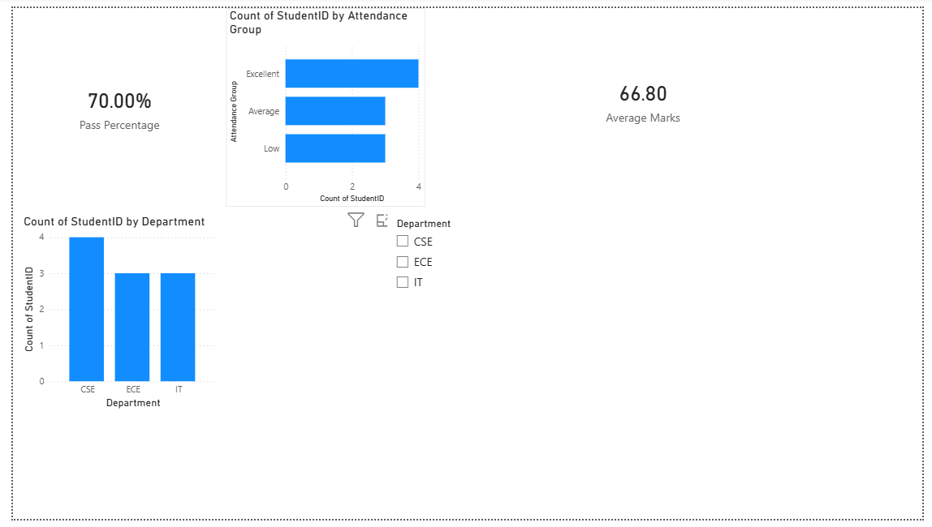

Dashboard Page Explanation:
This is my main dashboard for Student Performance Analysis using Power BI.
First, I imported the dataset and cleaned it using Power Query. I also created a new column called Attendance Group using conditional column.
At the top, these KPI cards are showing Pass Percentage, Total Students, and Average Marks.
In the middle, I created a chart for student distribution by attendance group, which shows Excellent, Average, and Low attendance categories.
At the bottom, I created a department-wise student count chart, which shows the number of students in CSE, IT, and ECE departments.
I also added a slicer for department filtering. When a department is selected, all visuals update automatically.

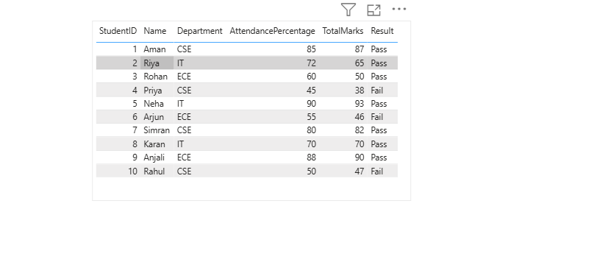

Students Details Page Explanation:
This page is created using drill-through functionality.
When I right-click on any department from the dashboard and select drill-through, this page opens and shows detailed student information for the selected department only.
Here, I displayed StudentID, Name, Department, Attendance Percentage, Total Marks, and Result.
This helps in analyzing student details in a more detailed and interactive way.

